**Business Process Modelling for HerWealth Platform**

1. Scope

The HerWealth platform serves as a model for women's financial empowerment, emphasising how users engage with the system to manage savings, make investments, conduct transactions safely, and get financial guidance to help them make better decisions.

Relevance to MIS

The procedure incorporates the concepts of Management Information Systems (MIS) by:

* AI powered financial insights for decisions support.
* Operational Efficiency (fraud detection and automated transactions)
* Security (Monitoring and data integrity)
* Customers service management (financial guidance and tailored advice)

Objectives and Outcomes

* Empowering marginalized women to digital financial resources
* Make co-investments possible and automate savings.
* Give individualised financial advices
* Assure data transparency and transaction security
* Encourage financial literacy and independence

Key Entities

|  |  |
| --- | --- |
| Entity/Actor | Role and Responsibility |
| User (Women) | Registers, manages savings, initiates transactions, seeks financial advice. |
| HerWealth System | Automates savings, investments, and handles transactions; generates AI-based financial insights. |
| Financial Advisor | Reviews AI-generated advice, ensures relevance before sharing with users. |
| Database | Stores user profiles, transactions, savings records, investment portfolios, and advisory data. |
| Fraud Detection Module | Monitors transactions in real-time to detect and prevent fraudulent activities. |
| Investment Portfolio | Provides investment opportunities and manages user participation and returns. |

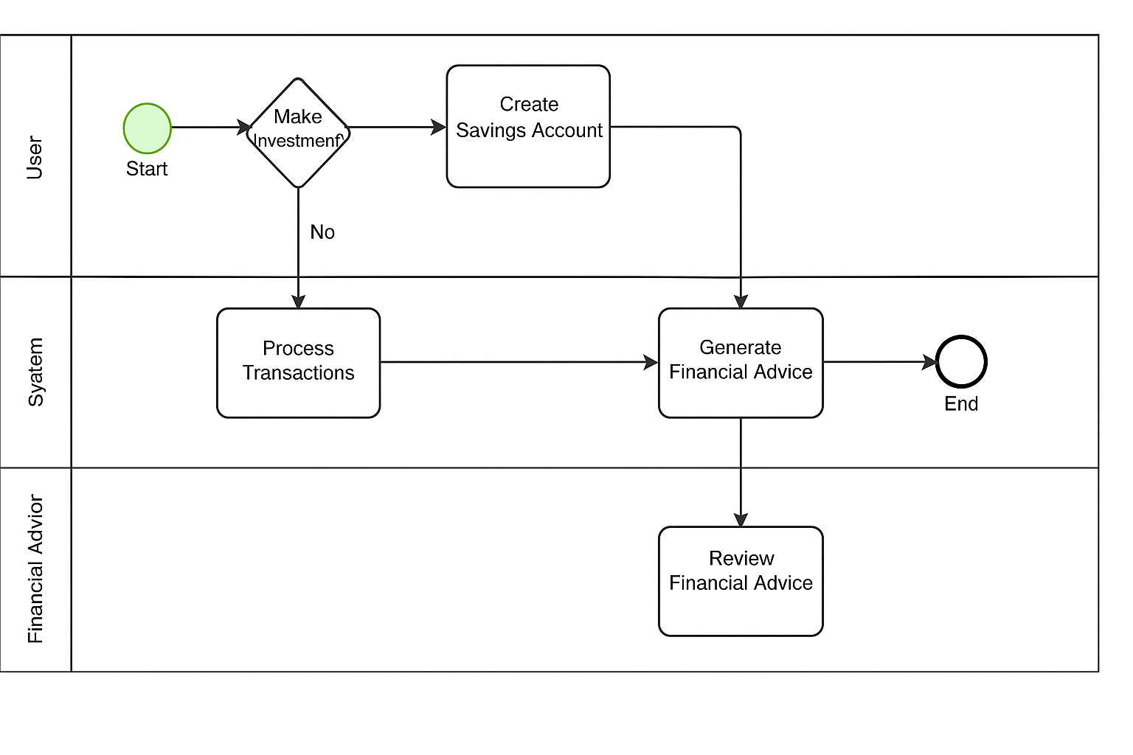

**An explanation of the Diagram above**  
The business process of the HerWealth platform, which aims to empower women by providing easily accessible digital financial services, is depicted in this BPMN model. By automating financial processes, facilitating decision-making with AI-generated financial insights, and guaranteeing data security and transparency, the procedure incorporates Management Information Systems (MIS) principles.  
  
  
*Start Event*

When a user visits the platform and registers or logs in, the procedure starts. This is the point of entry into the system.  
  
*Decision Point: Make an Investment*

Customers have to choose between using savings services or moving forward with investments. In order to direct users towards the appropriate financial path, this decision point is essential.

*Create Savings Account:*All users establish a savings account to manage money and keep tabs on their financial activities, regardless of whether they choose to invest.

*Process Transactions (System Responsibility):*  
The system manages all financial transactions, including deposits, withdrawals, and transfers. This guarantees efficiency and automates repetitive tasks.

*Generate Financial Advice (MIS Decision Support):*

The system employs AI models to produce tailored financial advice based on the user's financial information. By improving decision-making through data-driven insights, this directly supports MIS functions.

*Review Financial Advice (Financial Advisor):*  
To ensure a human-in-the-loop approach for higher service quality, the Financial Advisor verifies the AI-generated advice for correctness and applicability prior to it being shown to the user.

*End Event:*  
The process concludes after the financial advice is reviewed and either delivered to the user or stored for future access.

Phase 3:  
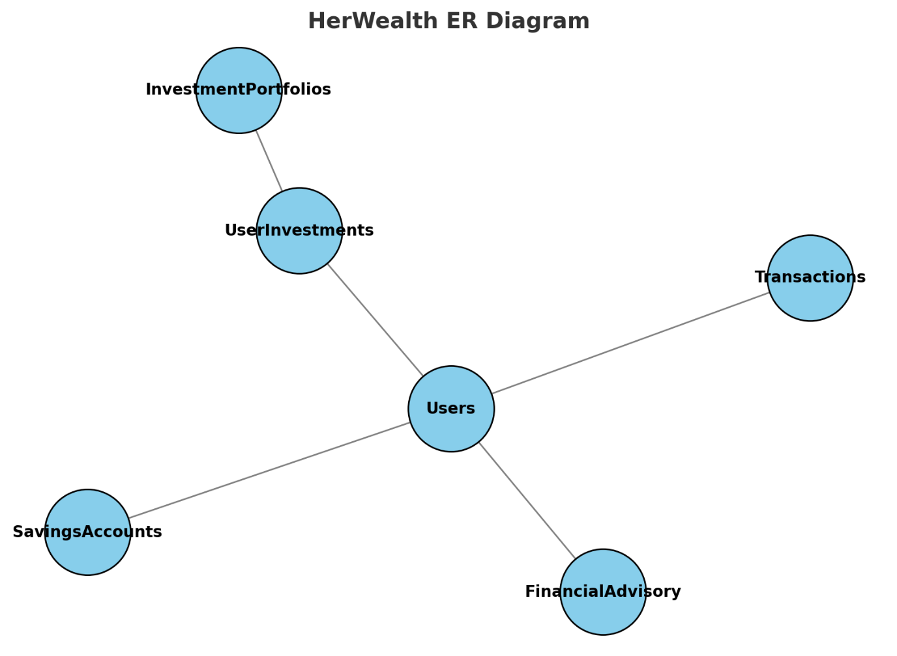

**Logical Data Model Explanation – HerWealth Platform**

**Entities & Relationships:**

1. **Users**
   * Attributes: UserID (PK), Name, Email (Unique), Phone, KYCStatus
   * Role: Central entity; interacts with all other entities.
2. **SavingsAccounts**
   * Attributes: AccountID (PK), UserID (FK), GoalAmount, CurrentBalance, StartDate, EndDate
   * Relationship: One user can have multiple savings accounts (1:N).
3. **InvestmentPortfolios**
   * Attributes: PortfolioID (PK), Name, RiskLevel, ReturnRate
   * Role: Stores available investment options.
4. **UserInvestments**
   * Attributes: InvestmentID (PK), UserID (FK), PortfolioID (FK), AmountInvested, InvestmentDate
   * Relationship: Many-to-Many between Users and InvestmentPortfolios.
5. **Transactions**
   * Attributes: TransactionID (PK), UserID (FK), Type (Deposit/Withdrawal/Transfer), Amount, TransactionDate
   * Role: Logs all financial transactions; linked directly to Users.
6. **FinancialAdvisory**
   * Attributes: AdviceID (PK), UserID (FK), AdviceText, CreatedDate
   * Role: Stores AI-generated financial advice for each user.

The model is compatible with:

* Each user has multiple savings objectives.
* A variety of investment options.
* Safe monitoring of every transaction.
* Tailored financial guidance according to user behaviour.

Phase 7:  
**Problem Statement**

**Enhancing Security and Compliance through Advanced Database Programming & Auditing**  
HerWealth must ensure that financial data manipulations are strictly controlled, logged, and compliant with business rules. We need to prevent any INSERT/UPDATE/DELETE operations during weekdays and on public holidays (to avoid after-hours or policy-violating changes), and simultaneously maintain a full audit trail of all user actions. Triggers and packaged logic will enforce restrictions, while an audit table will capture every attempted operation—allowed or denied—thus improving security, accountability, and regulatory compliance.

**Justification**

* **Triggers** enforce real-time business rules (e.g., blocking DML on restricted days) directly in the database layer, preventing any bypass via application code.
* **Packages (simulated)** group related procedures/functions—here, we simulate an Oracle-style package by logically grouping our audit‐related routines—improving modularity and maintenance.
* **Auditing** via a dedicated AuditLog table records user ID, table name, operation, timestamp, and whether it was allowed or denied, ensuring traceability for compliance and forensic analysis.